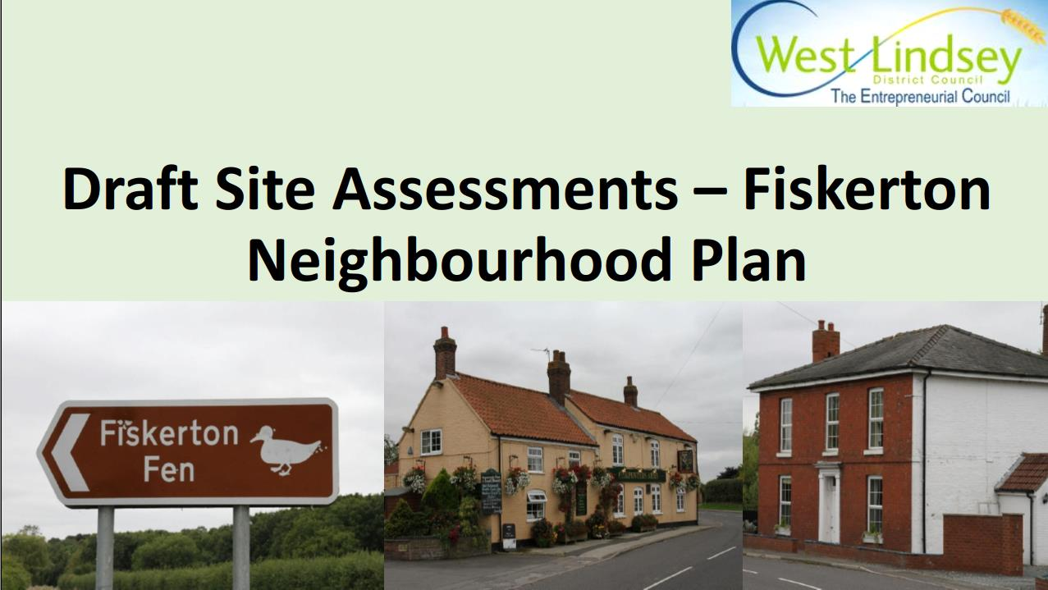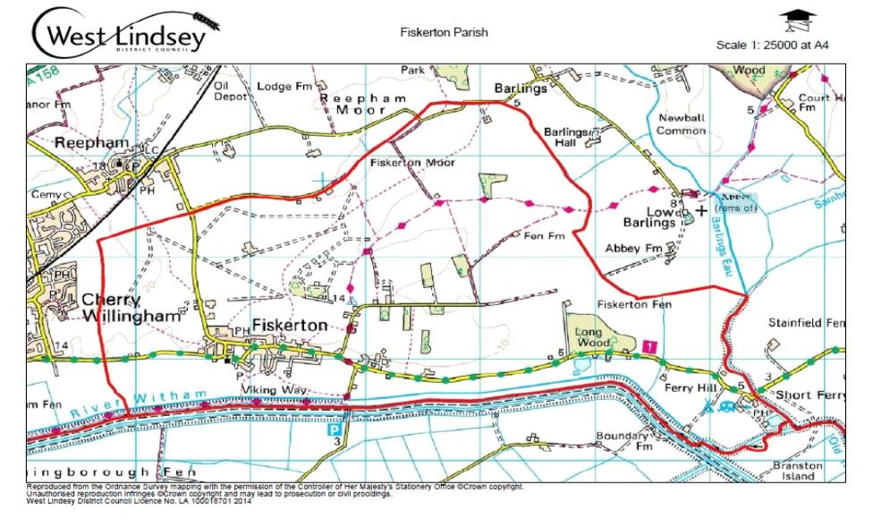
Revised 28 August 2021.
Fiskerton Parish Council.
The Neighbourhood Plan Area.

Sites reviewed resulting from December 2019 Fiskerton Parish Council Questionnaire feedback.
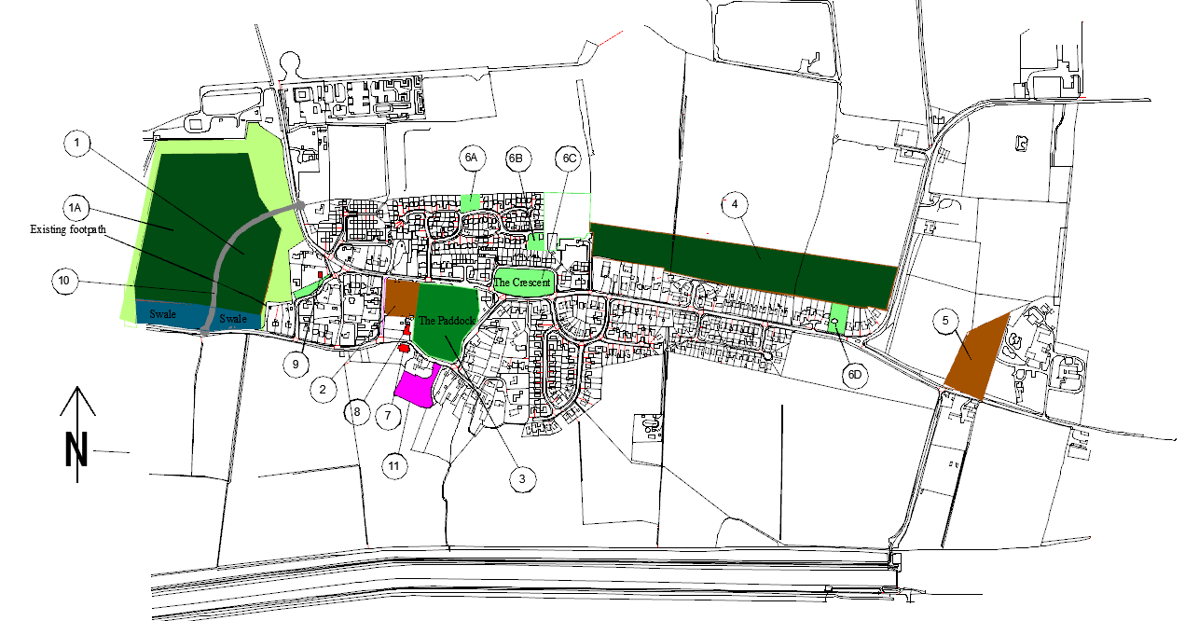

NOTE:
The boundaries of area 1A and its surrounding green wedge are subject to change pending information on the Primetake explosive restriction zones.
Area 4 is an amalgamation of two separately defined sites in the 2019 Parish Survey. They are shown as one area to reflect the proposed allocation in the draft CLLP 2021.
Key to Sites and developments.
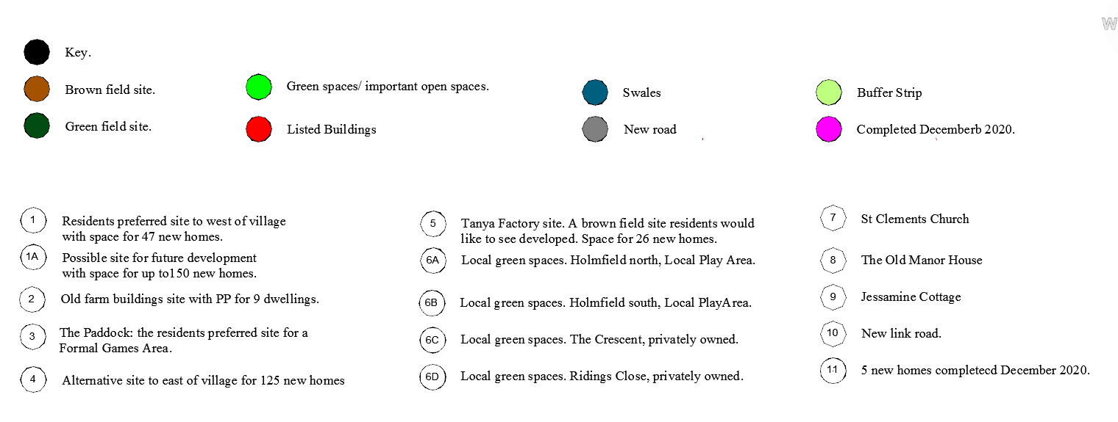

Where can the houses go?

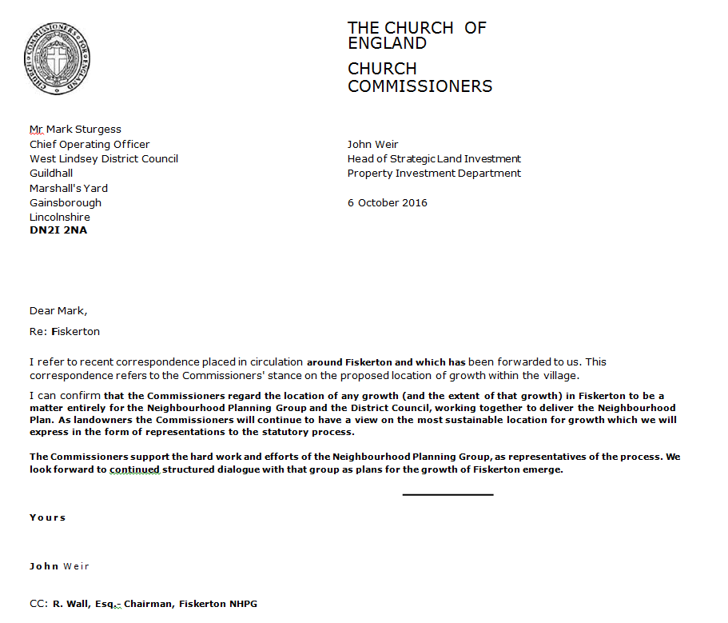
Site Allocation - Assessment Criteria
Introduction
This report assesses all the sites identified through emerging Neighbourhood Plans and their potential for including site allocations for housing development in a specific Neighbourhood Plan Area. The sites considered have come from two main sources:

- sites submitted to the District Council as part of the Central Lincolnshire Local Plan's SHELAA; and

- other sites identified through a Neighbourhood Plan 'call for sites' which the community and steering group felt were worthy of consideration.
This assessment is designed to identify whether the areas of land are either available, suitable and deliverable for their inclusion into a Planning Policy document as a formally development allocation.
Purpose of this Assessment
National Planning Policy requires Local Plans, which includes Neighbourhood Plans to be informed by robust and credible evidence through research and evidence. It also makes it clear that allocated sites should be 'deliverable' within the identified plan period.
An important role of this work is to provide an assessment of the Neighbourhood Plan Area's supply of deliverable sites. To be considered deliverable, the NPPF states that sites should, at the point of adoption of the Neighbourhood Plan be:
- Available — the site is empty and available now
- Suitable - the site offers suitable location for development
and will contribute to the sustainability of the area;

- Deliverable — there is a reasonable prospect that housing
will be delivered on the site within the timeframes identified.

Fiskerton Neighbourhood Plan — Housing Requirement
Fiskerton Neighbourhood Plan is seeking to identify enough land within the Neighbourhood Plan Area to allocate, at least, 47 new homes over the plan period. This has been allocated due to looking at current and future demographic projections and in order to secure the paddock as a community green space residents may be persuaded to accept up to 200 new homes.
The site assessments and public consultation will determine which sites go forward into the Neighbourhood Plan and the level of growth to be delivered through the plan period until 2041.

Fiskerton* 465 10% 47 9 0% 47 * Based on the number of properties in the core of the village currently built, but ignoring the 9 new homes that have Planning Permission but are not yet built.

Site Assessment Methodology.
The site assessments must provide a robust method by which all potential housing sites within the Neighbourhood Plan Area can be identified.
Sites must be assessed on the basis of their social, economic and environmental constraints which will determine their suitability for development.
How will the Site Assessments be undertaken?
The site assessments involve a number of assessments, including:
- A site visit to identify all 'known' physical constraints;
- A desktop search for their existing planning history and conformity or conflict with existing National and Local Planning Policy;
- A consultation with relevant agencies in order to confirm any social. Economic or environmental constraints.
Carrying out the Site Assessments
In order to ensure that surveys were carried out on a consistent basis, a standard proforma was used.
Estimating the Housing Potential of each Site
Existing Government guidance identifies sites should be guided by existing policy. In this case, 24 dwellings per hectare was used. This however, may change through the allocation process.

Screening Criteria Methodology
Sites were scored against each criterion using a traffic light system, with green indicating no conflicts, yellow indicating some or minor issues (that could be overcome (mitigated)) and red indicating direct conflict (unlikely to mitigate).
The criteria are not 'weighted'. Although the sites with the highest number of green lights are regarded as more desirable (with fewer adverse effects), sites have not been ranked on this basis alone. Likewise, red lights do not automatically discount sites. Rather, they simply show that the site has issues requiring greater mitigation or has impacts that may be balanced against other factors in the assessment (e.g., its ability to deliver significant local benefits). As such, in instances where sites have accrued yellow or red lights, mitigation measures can potentially deliver a range of benefits for the wider community. The results of each site should reflect which are the most and/ or least constrained.
Once assessed, sites will then be 'ranked' on whether they are 'available, 'suitable' and 'deliverable' and a recommendation on whether they then proceed to the next stage, which is the 'preferred' locations for development.
Sites that are 'ranked' as either 'YES' or 'MAYBE' will proceed as a 'preferred' site. Sites that are ranked as 'NO' will not proceed to the 'preferred' site stage of the process.

1. Is the Site suitably Located
To comply with the sustainability criteria of the Local Plan and the National Planning Policy Framework, sites should be easily accessible, by foot, to jobs, shops, doctors, schools, recreational facilities, public transport and other services. New developments should be located with available access, via footpaths, cycle ways and Public Transport to nearby services and facilities. For rural communities, developments should be located within the existing built form of the largest settlement, if possible.
The Department for Transport (DfT) advise that the 'mean average length for walking journeys is approximately 1km. The best standard is for developments to be within 400-800m of nearby facilities. It is also considered that a reasonable walking distance of 2km is possible for some sectors of the community (namely with larger settlements).
Site Reference Distance to Primary School (m)
1 684
1A 754
2 454
3 335
4 433
5 848

The site WOULD BE accessible (walking distance 400m) to a

G
A
R
number of services and facilities within the community.
The site MAY BE accessible (walking distance (within 400m — 800m))
to some services and facilities or may be able to provide enhanced or
additional services a part of a development.
The site WOULD NOT be accessible (walking distance (800m — 1km or above)
to local services and facilities.

2. Is the landowner supportive of developing the site?
Ensuring that the landowner of the site is willing and able to bring the site forward for development is a key consideration when determining which sites should be allocated through the Neighbourhood Plan process.
Engaging with landowner is part of the Site Selection process and all landowners were invited to discuss their site and any potential issues with the site coming forward. It is fundamental to establish whether the site can be released for development (such as is there a long-term lease on the site or a restrictive covenant which would prevent the site being sold?) and the willingness of the landowner to do so.
Feedback from each landowner will be a major factor when determining the preferred sites. Without the landowner's support, it is unlikely that the site will come forward and therefore will have a significant impact on the delivery of the Neighbourhood Plan's aspirations. If a site is deemed undeliverable, then it cannot be allocated in a Neighbourhood Plan.
Sites will therefore be assessed as follows:

The landowner is in favour of the development taking place

There are some concerns about the land ownership or uncertainty

No comments were expressed from the landowner/no known issues

There are strong concerns about the land ownership or the
likelihood of the site coming forward.

3. Is the local community supportive of the development of the site?
Public opinion, where it is based on legitimate planning concerns, is a fundamental consideration in the site allocations process, which is strengthened further within Neighbourhood Planning. As such, on-going public consultation is integral to the continued preparation of the Plan.
The level of support expressed by respondents to consultation for or against a particular site is a significant factor in the decision-making process of the preparation of a Neighbourhood Plan. It will be particularly important where there are a number of sites in the Plan area between which it is difficult to decide or which have equal 'scores'.
It is recognised that land owners or prospective developers may hold their own independent consultation with local communities to gauge support for the development of a site. Where the results of these consultation exercises have been published, they will be considered accordingly. However, conclusions will be primarily based on responses received through consultation undertaken on the Neighbourhood Plan. Consultation responses on each site will be considered as follows (taking account of the fact that some sites may have had no comments made for or against them):
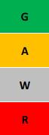
A majority of respondents expressed support for the
development of the site for the proposed use

A balance of views was expressed for the development
of the site for the proposed use

No comments were expressed about the development of
the site for the proposed use

A majority of respondents expressed an objection to the
development of the site for the proposed use

4. Will the development of the site be compatible with existing and/ or proposed neighbouring land use(s)
From the point of view of both existing public amenity and that of the occupiers of new development sites, it will be essential to ensure that new development is compatible with its surroundings, taking into consideration, for example, issues of noise, odour, light or privacy. For example, new housing is unlikely to be compatible with an existing heavy industrial site and vice versa.
Sites will be classified as follows:
Is compatible with existing and proposed uses (low impact)  residential and agricultural. | G
Likely to Likely to be compatible with existing and proposed uses  (Potential (potential impact), light industry, farms, schools, and  public open spaces  ces. | A
Likely to be incompatible with existing and proposed uses  (Hazardous impact) pollution, heavy industries  factories, MOD sites. | R

Will the development result in the loss of the best and most versatile agricultural land?

Natural England's Agricultural Land Classification separates land into five grades (and further subdivides grade 3 into 3a and 3b). Grades 1, 2 and 3a are regarded as the best and most versatile agricultural land. Grades 3b, 4 and 5, are seen as being of poorer quality.

Under Schedule 5 of the Development Management Procedure Order Natural England must be consulted for single (individual) applications for the following:

'Development which is not for agricultural purposes and is not in accordance with the provisions of a development plan and involves— (i) the loss of not less than 20 hectares of grades 1, 2 or 3a agricultural land which is for the time being used (or was last used) for agricultural purposes; or (ii) the loss of less than 20 hectares of grades 1, 2 or 3a agricultural land which is for the time being used (or was last used) for agricultural purposes, in circumstances in which the development is likely to lead to a further loss of agricultural land amounting cumulatively to 20 hectares or more' (Schedule 5).

Advice may also be sought from Natural England regarding the potential impact of cumulative loss of agricultural land (in order to avoid future site allocations being refused planning permission on this basis). The National Planning Policy Framework (NPPF) states (para. 112) that:

'Local planning authorities should take into account the economic and other benefits of the best and most versatile agricultural land. Where significant development of agricultural land is demonstrated to be necessary, local planning authorities should seek to use areas of poorer quality land in preference to that of a higher quality'.

Ref: The Town and Country Planning
(Development Management Procedure) (England) Order 2010.

West District Council acknowledged that the rural character of West Lindsey as being
one of the district’s most distinctive and valued features. To ensure that loss of land most
valuable for agricultural purposes is minimised wherever possible, the Plan should seek
to allocate known areas of poorer quality land, unless there are benefits (identified through
the other screening criteria) to be achieved that outweigh retention of the land for
agricultural use. There are two categories of agricultural land classification within
the village, as shown on the map below:
Because data to distinguish between grade 3a and 3b land across West Lindsey is
currently unavailable, sites located on grade 3 land will be categorised as yellow.
It is felt that this represents a precautionary approach that is neither unnecessarily
restrictive nor dismissive of the potential value of sites currently in agricultural use.

Sites will be assessed as follows:
The site is located on grade 4 or lower,
or is previously developed.

Less than 50% of the site is within grade 1 or 2
land and/ or within grade 3 land and/ or
is previously developed.

50% or more of the site is within grade 1 and grade 2
land and is previously undeveloped.

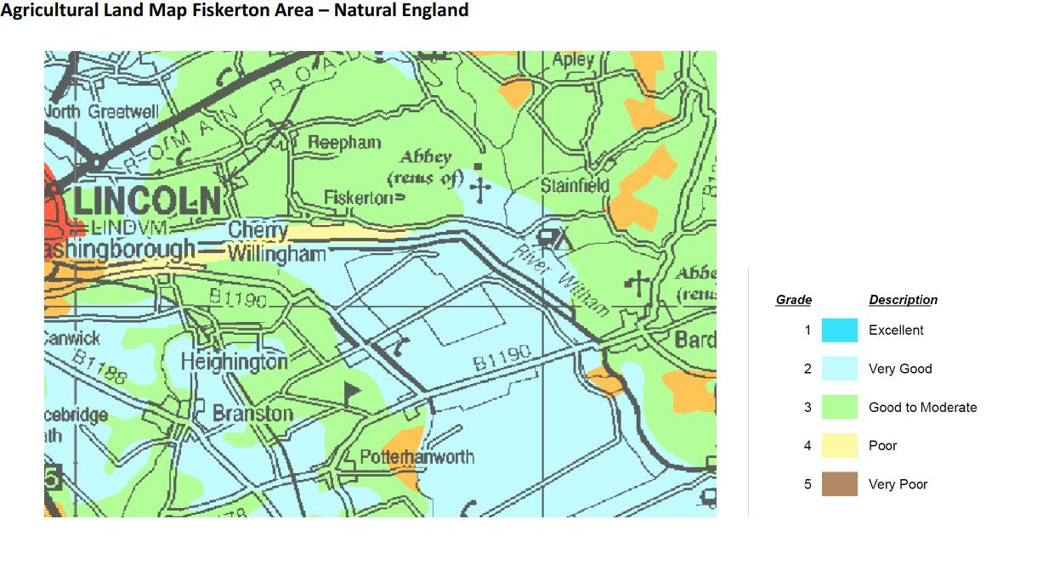

6. Is the site constrained by and environmental (European/ National/ Local designations?

The importance of environmental protection and enhancement is a key consideration
of the planning process. It is vital that proposed sites are
assessed according to their potential to impact upon the wider environment.
This will include National Wildlife Sites, Local Wildlife Sites, Ancient Woodland,
Geological Sites and Tree Preservation Orders.

Sites will be assessed as follows:

The site does not have any environmental constraints
and is not within 100m of a designated site

There are some environmental constraints on the site
which could be mitigated.

The site has environmental constraints that cannot be mitigated.
The site lays within 100m of a designated site.

Protected Environmental Sites — Natural England
Reproduced from the Ordnance Survey mapping with the permission of the Controller of Her Majesty's Stationery Office ©Crown copyright

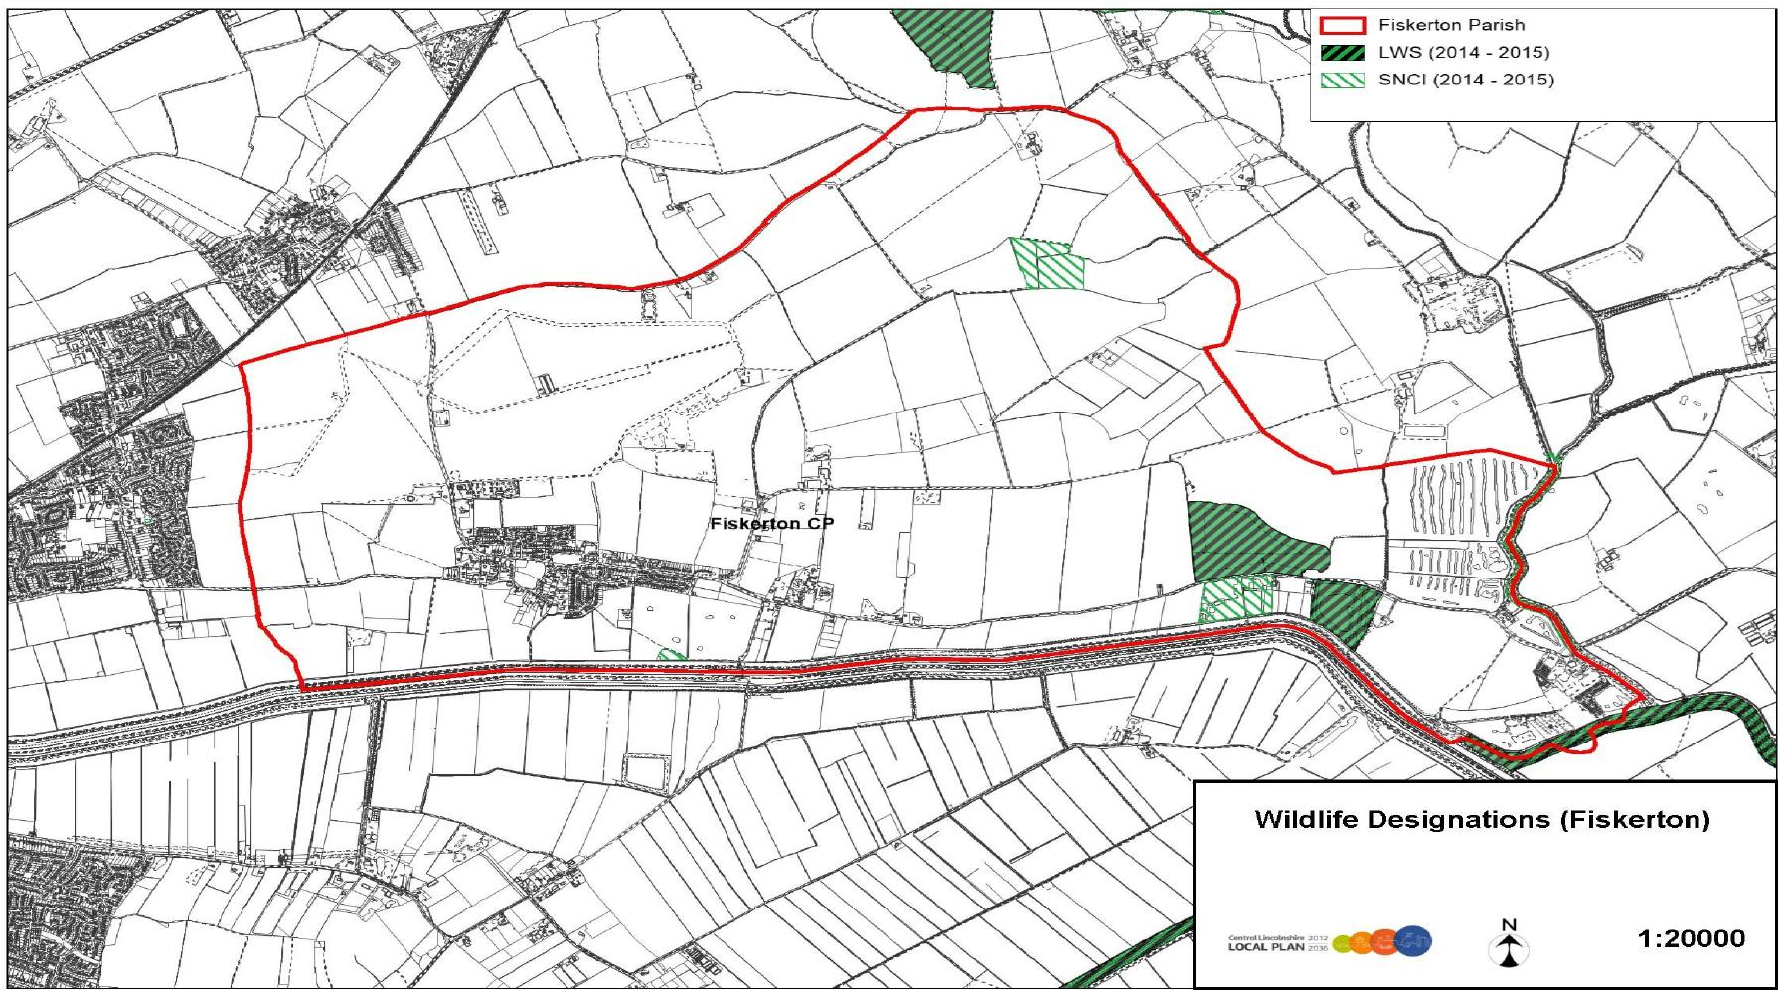
Fiskerton Parish LWS (2014 - 2015)
SNCI (2014 - 2015)
Unauthorised reproduction infringes ©Crown copyright and may lead to prosecution or civil proceedings.
City of Lincoln Council Licence No. LA 100018414 North Kesteven District Council Licence No. LA 100017926 West Lindsey District Council Licence No.

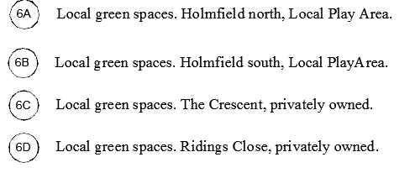
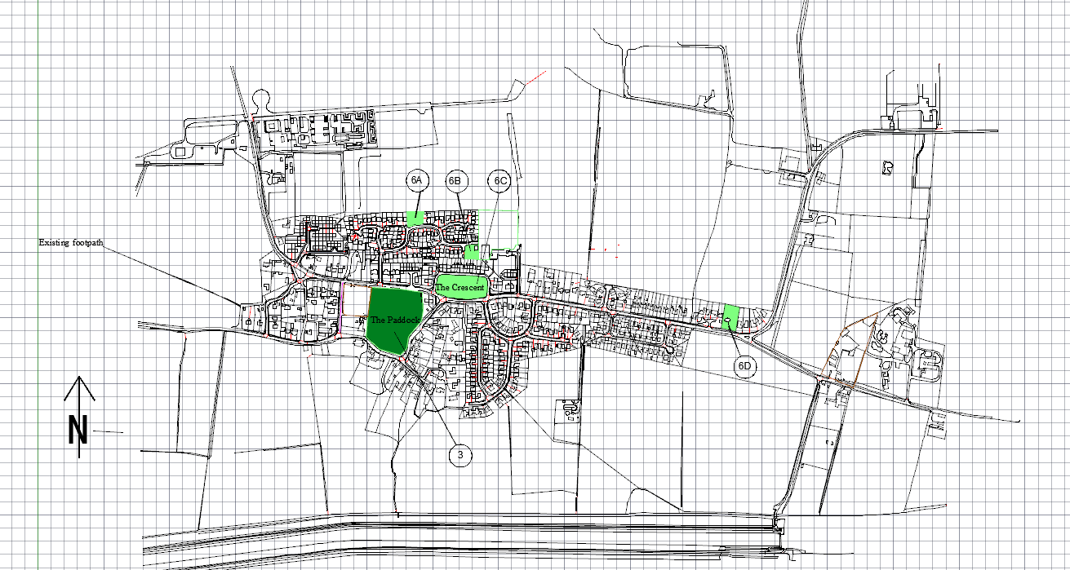
Local Green Space
7. Will the development detract from or enhance the existing built character of the neighbourhood?
Many settlements within West Lindsey have a sensitive built form, which it is desirable to protect and enhance. Conversely, there are a number of areas that would benefit from new development where it would result in a positive impact on a derelict site or poor-quality streetscape. The site should be within or directly adjoining the existing 'built form' of the settlement.
Assessing the aesthetic merits of a design is an inherently subjective
process and while it is clearly not possible to assess the impact of a
development scheme at this early stage, some sites may represent more
logical extensions to the existing built

Sites will be assed as follows
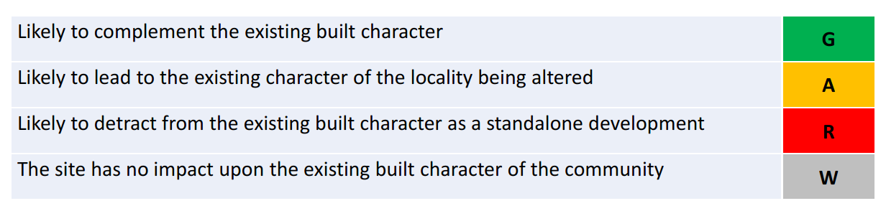

8. Will the development detract from or enhance the existing Green Infrastructure of the neighbourhood?
Green Infrastructure is a network of multi-functional green spaces in both rural and urban areas; development of a greenfield site may not, by definition, lead to the loss of a Green Infrastructure asset. These green spaces support natural and ecological processes and are integral to the health and quality of sustainable communities.
In line with the District Council's Local Plan policies, it is important to minimise adverse impacts on Green Infrastructure assets, new development can also generate opportunities to protect, enhance, restore and even create habitats and species' populations. They may also provide opportunities to create, enhance or provide greater access to green spaces. These opportunities will be considered through the screening process, taking into account all information that is available.
Sites will be assessed as follows:

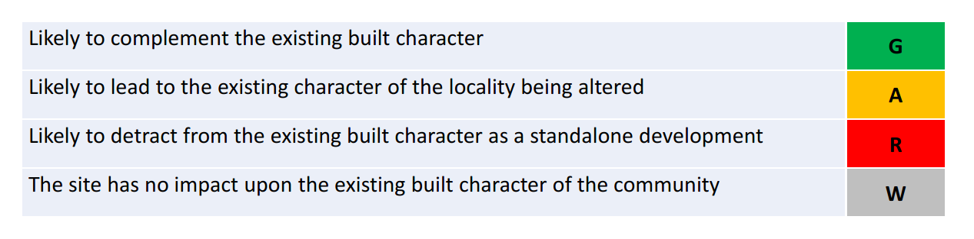

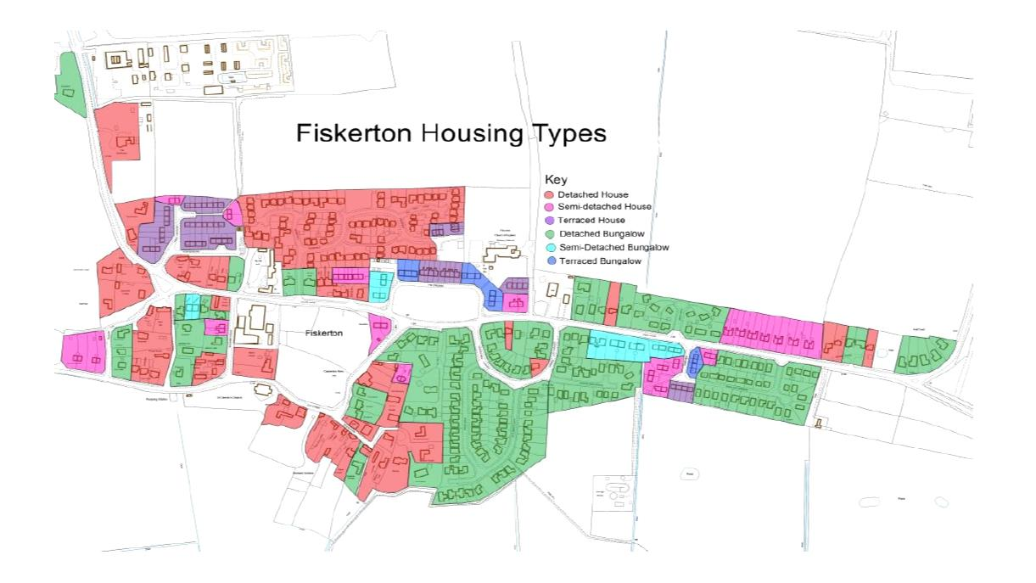

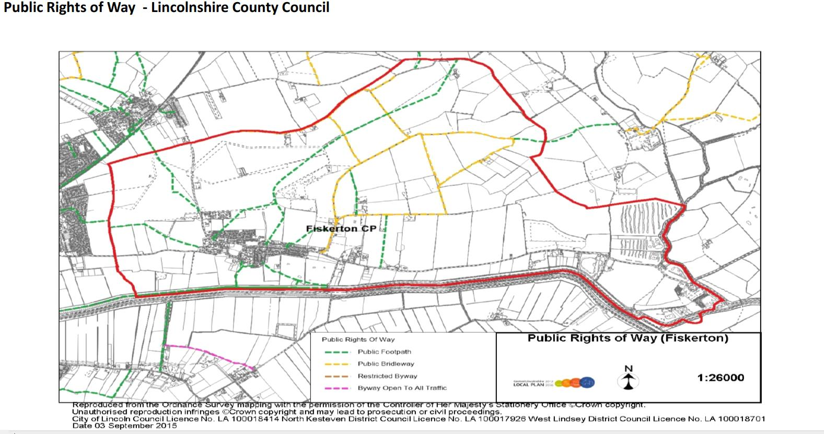

9. Will the site impact upon identified and unseen heritage assets (including setting)?

No suggested sites will have a significant adverse impact on identified heritage assets within this Site Assessment. However, there may be hidden archaeological sites or artefacts that will need to be investigated before individual planning permissions are granted.

Identified heritage assets include: 3 Listed Buildings.
Sites will be assessed as follows:
Grade I, II or II* Listed Building, Ancient Monument or Historic Park nearby.
Grade I, II or II* Listed Building, Ancient Monument or Historic Park Grade I, II or II* Listed Building, Ancient Monument or Historic Park on the site.
There are 3 Grade 11 Listed Buildings in the village, St Clement’s Church, the Old Manor House and Jessamine Cottage. None will be adversely affected by any of the proposals.

11. Would there be a flooding impact to the site or surrounding area?
It is important to identify whether new developments will have an impact on the flood risk to an area. Due to its low landscape and large network of watercourses, a significant number of communities within West Lindsey are located within a medium — high risk zone of flooding potential.

Sites will be assessed as follows:

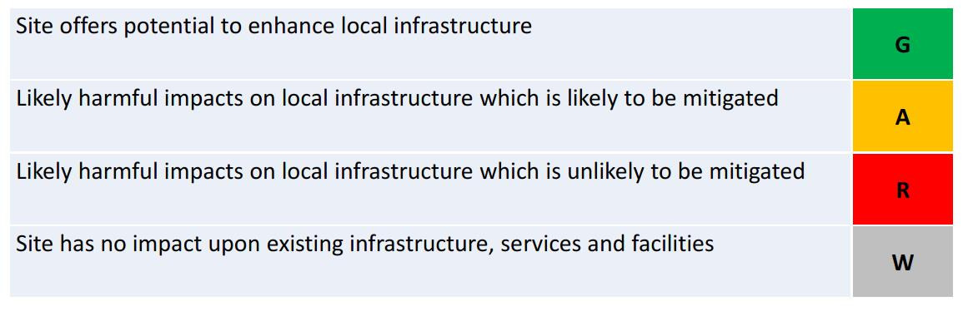

Flood Risk Map— Environment Agency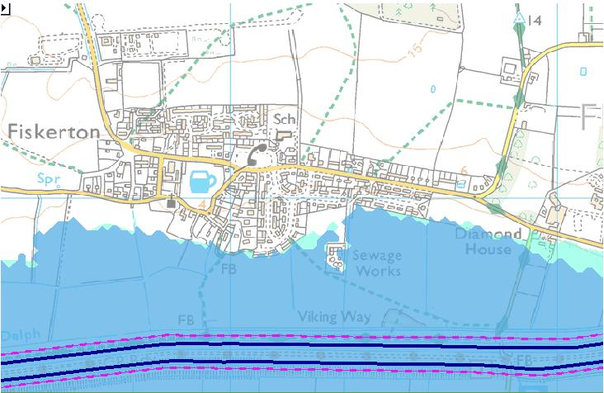 | Flood Zone 3  Flood Zone 2

Public Consultation — Identifying Site Availability

Due to earlier discussions and consultation exercises on development, and the October 2019 parish survey, it was agreed that the Parish Council would now look at three possible new sites for housing development and one for which planning permission has been approved, and two possible sites for recreational use and would undertake discussions with the largest landowners- the Church Commissioners and the owner of the Tanya site with regards to land availability. The Church Commissioners own the majority of 'developable' land around Fiskerton and they therefore play an important role in assessing the potential availability and suitability of land for this Neighbourhood Plan.

All the sites, with the exception of the Tanya site are let on an agricultural tenancy basis, and a satisfactory settlement between land owner and tenant will need to be reached. The Tanya site is on the market and could be developed as soon as planning permission was gained.

Fiskerton Potential Development Sites
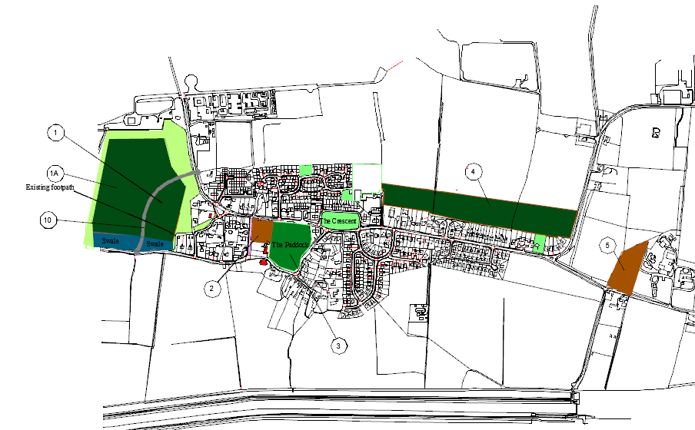

Site 1

NOTE:
The boundaries of area 1A and its surrounding green wedge are subject to change pending information on the Primetake explosive restriction zones.
Area 4 is an amalgamation of two separately defined sites in the 2019 Parish Survey. They are shown as one area to reflect the proposed allocation in the draft CLLP 2021.

Site 1 &1A Land to the West of Fiskerton
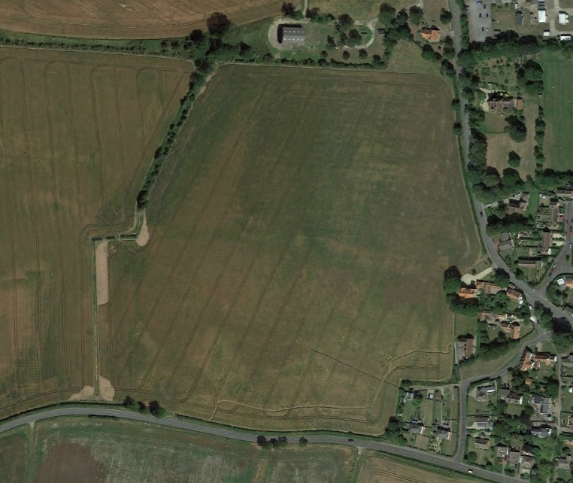
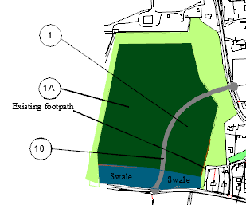

Statistics

Site Size (ha) 11.98

Development Size Site 1 3.3&
Site 1A 8.8 .

Site Capacity Site 1 up to 50 new homes
Site 1A up to 150 new homes

Comments

Grade 3 Agricultural land.
Utilities are adjacent to the site but the site will require new infra structure in proportion to the number of houses planned.
Some impact on the environment.
Would alter the existing character of the village.
Would keep extra traffic out of village.
No impact on local flooding hot spots but the development will need to meet SUDs requirements.
Reduced travel distance to Lincoln – lower carbon footprint.
Space for new link road between Lincoln Road and Reepham Road
Preferred location for new development in 2019 survey.
Outside the existing curtilage of the village.
Possible below ground archaeological remains will need investigating.

Development timescale

The land is currently let on an agricultural lease.

Likely availability 1 to 5 years.

Planning status~ Available.

Site 2 Land adjacent to the Paddock
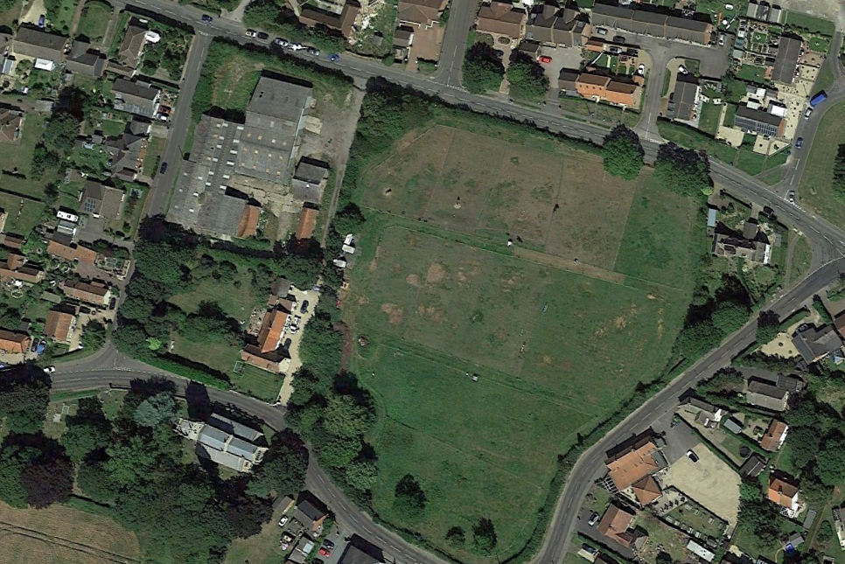
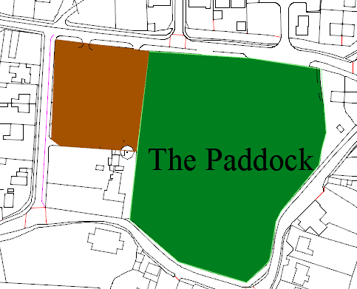

Statistics

Site Size (ha) 0.42

Development Size 0.42

Site Capacity 9 New homes, Planning Permission granted.

Comments

Brown field site.
Utilities are adjacent to the site but the site will require new infra structure in proportion to the number of houses planned.
Some impact on the environment.
Will alter the existing character of the village.
Little impact on local flooding hot spots but the development will need to meet SUDs requirements.
Reduced travel distance to Lincoln – lower carbon footprint.
Space for new link road between Lincoln Road and Reepham Road

Preferred location for new development in 2019 survey.

Development timescale

Immanent.

Site 3 the Paddock
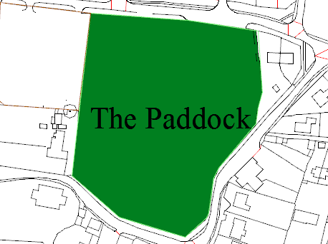

Statistics

Site Size (ha) 1.65

Development Size 1.65

Site Capacity None Space required for a formal games areas.

Comments

Low grade agricultural land.
Utilities are adjacent to the site.
Some impact on the environment.
Will not alter the existing character of the village.
No extra impact on local flooding hot spots.
The is no provision for formal sports and recreation in the village or within 1200m of the village centre.
The Local Plan documents recommend 0.80 ha per 1000 population. With a current population of 1200 1.0 ha would be required now.
Development timescale

The land is currently let on an agricultural lease.

Site 4 Land to the North of Ferry Rd
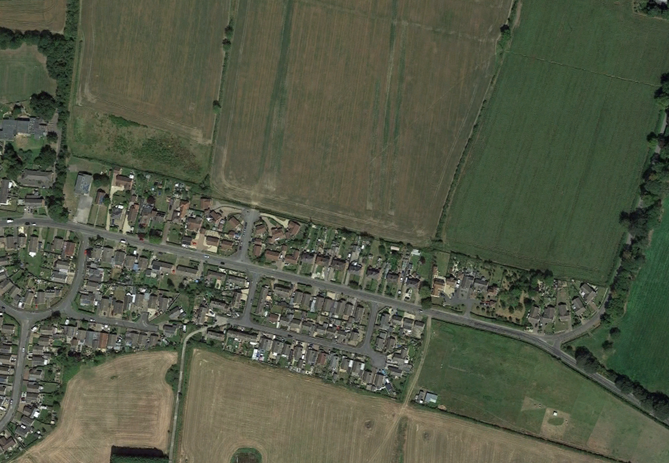
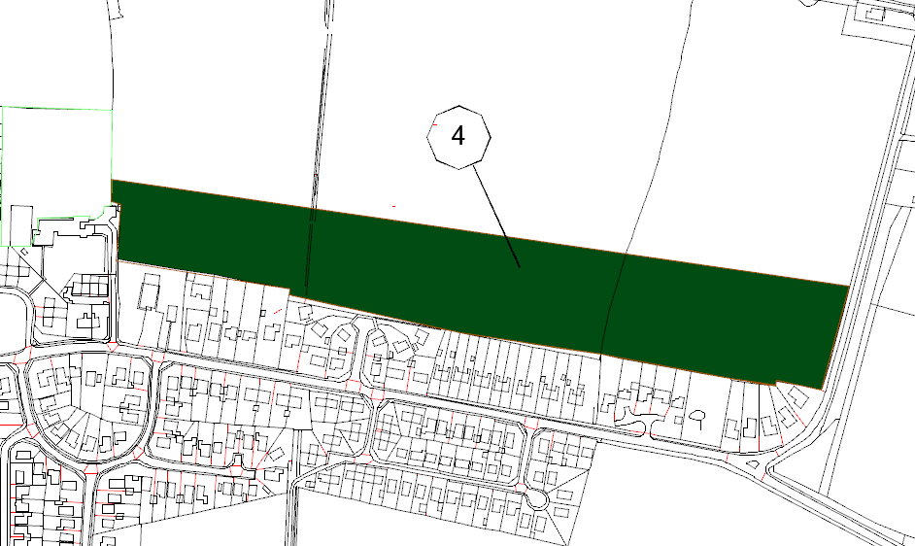

Statistics

Site Size (ha) 8

Development Size 8

Site Capacity Site 1 up to 125 new homes

Comments

Grade 3 Agricultural land.
Utilities are adjacent to the site but the site will require new infra structure in proportion to the number of houses planned.
Some impact on the environment.
Would alter the existing character of the village.
Would not keep extra traffic out of village.
Impact on local flooding hot spots, the development will need to meet SUDs requirements and above to not worsen existing problems.
Increased travel distance to Lincoln – higher carbon footprint.
No provision for a link road between Lincoln Rd and Reepham Road.
Least preferred location for new development in 2019 survey.
Outside the existing curtilage of the village.
Development timescale

The land is currently let on an agricultural lease.

Likely availability 1 to 5 years.

Planning status~ Available.

Site 5 Tanya Knitwear factory
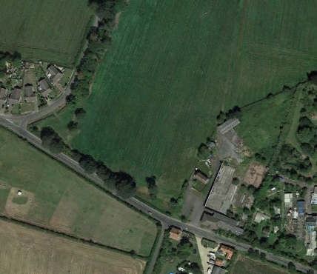
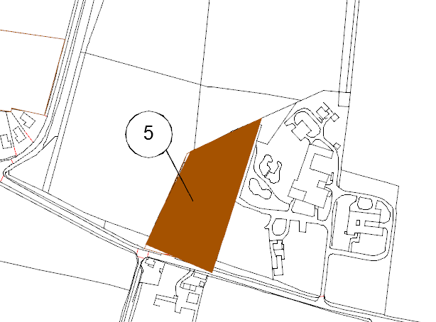
Land to the East of Fiskerton.

Statistics

Site Size (ha) 1.07

Development Size 1.07

Site Capacity Site 1 up to 26 new homes

Development timescale

Likely availability Now.

Planning status~ Subject to incorporation in the Neighbourhood plan.
Comments

Brown field site.
While part of a cluster of buildings, the site is nearly 200m from the eastern edge of the curtilage of the village.
Utilities are adjacent to the site but the site will require new infra structure in proportion to the number of houses planned.
Some impact on the environment.
Would alter the existing character of the village.
Would not keep extra traffic out of village.
Some impact on local flooding hot spots and the development will need to meet SUDs requirements.
Some contaminated ground considerations.
Support for development in the2019 survey.

Summary of site selection criteria.

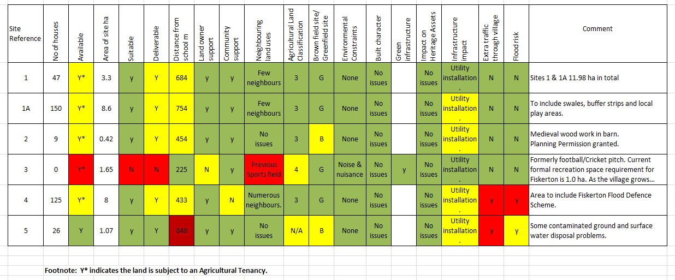

Outcome of assessment and Site Selection.

Fiskerton has a number of areas that have been identified for potential development and allocation within the Neighbourhood Plan. The main landowner for the area has strongly indicated the choice of land to be developed is the responsibility of the Parish Council. As part of the Neighbourhood Planning and National Planning Legislation, planning policy documents can only seek to formally allocate areas of land for development if they are considered 'deliverable'. The Site Selection Criteria provides an overall quick assessment on a number of 'reasonable' planning issues and themes. The Criteria's main aim is to provide some initial information about the availability, suitability and deliverability of identified areas of land for potential development and inclusion within the Neighbourhood Plan. The assessment of each identified area of land around Fiskerton village has been carefully considered the potential for future development and new Neighbourhood Plan avoids any 'known' constraints/ issues that could affect availability, and suitability or deliverability of each area of land.

Conclusion.

Any future development in the village over and above infill will require building outside the existing curtilage of the village.

Generally, this would require the new site to be adjacent to an existing boundary and this criterion is met with both Sites 1 and Site 4 but Site 5, the Tanya Knitwear Factory brown field site is nearly 200m from the eastern boundary of the village. In recent surveys the majority of residents have wished to see the site developed and included in the plan.

Of the two options for Sites 1& 1A and Site 4, building to the west of the village was the preferred choice in the 2019 survey and is technically preferable to building to the east for the reasons already given.

Site 1
Comments

Grade 3 Agricultural land.
Utilities are adjacent to the site but the site will require new infra structure in proportion to the number of houses planned.
Some impact on the environment.
Would alter the existing character of the village.
Would keep extra traffic out of village.
No impact on local flooding hot spots but the development will need to meet SUDs requirements.
Reduced travel distance to Lincoln – lower carbon footprint.
Space for new link road between Lincoln Road and Reepham Road
Preferred location for new development in 2019 survey.
Outside the existing curtilage of the village.
Possible below ground archaeological remains will need investigating prior to commencement of building.

Site 4

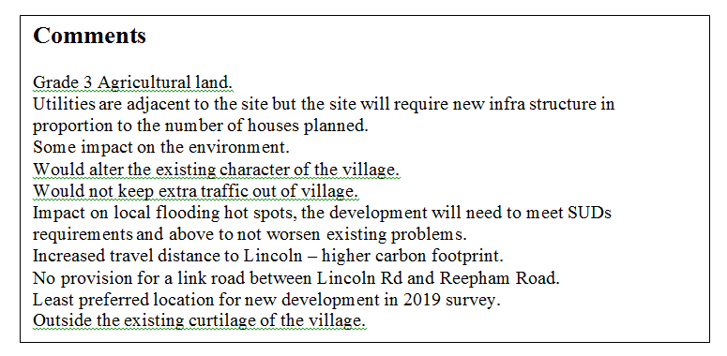

Site 5,

Comments

Brown field site.
While part of a cluster of buildings, the site is nearly 200m from the eastern edge of the curtilage of the village.
Utilities are adjacent to the site but the site will require new infra structure in proportion to the number of houses planned.
Some impact on the environment.
Would alter the existing character of the village.
Would not keep extra traffic out of village.
Some impact on local flooding hot spots and the development will need to meet SUDs requirements.
Some contaminated ground considerations.
Support for development in the2019 survey.

With the December 2019 survey results showing a majority wish for fewer than 75 houses be included in the Neighbourhood Development Plan, up to 50 houses on Site 1 and 26 new dwellings on Site 5 would meet that requirement.

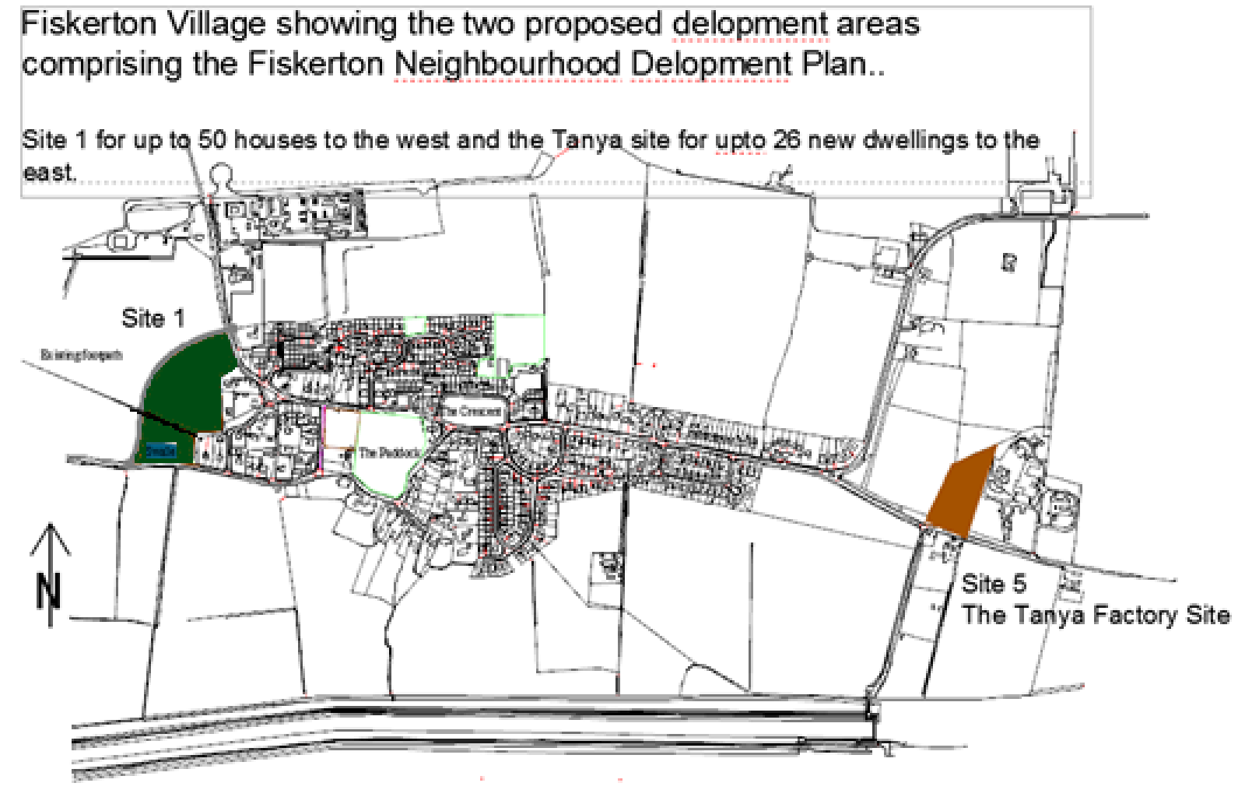

Should more houses be necessary to pay for the new link road or to acquire the Paddock for recreational use Site 1A with space for 150 new homes in addition to Site1 could meet that need.

