Central Lincolnshire Local Plan
Regulation 18 Consultation June 2021

Consultation Response Form

From 30 June to 24 August 2021 we are consulting on the Draft version of the Central Lincolnshire Local Plan, plus the accompanying Sustainability Appraisal (SA) and Habitats Regulations Assessment (HRA). This is the second of three rounds of consultation on this new Plan, which can be viewed at:

www.central-lincs.org.uk

This form can be used for responding to the consultation, however we would prefer you to make comments online using the Online Consultation Portal found at the link above. Alternatively you can email this form to talkplanning@central-lincs.org.uk or post it to Central Lincolnshire Local Plan Team, c/o North Kesteven District Council, Kesteven Street, Sleaford, NG34 7EF.

All comments must be received by 11.59pm on 24 August 2021. Late comments will not be accepted.

Part A: Your Details
Name: Michelle Vail | Agent name:
Organisation: Fiskerton Parish Council | Organisation:
Address:  8 Lacy Close  Nettleham, Lincoln  LN2 2WF | Address:
Postcode: LN2 2WF | Postcode:
Email: clerk@fiskerton-lincs.org.uk | Email:
Tel: 07305 818857 | Tel:
Signature:  (not required for electronic submission) | Date:

Important information about data protection:
Any comments you make as part of the consultations into the Central Lincolnshire Local Plan will be made public as it is a statutory requirement to publish comments. We will publish these online. If you have any concerns then please contact us. The Councils will however remove personal email addresses, postal addresses, telephone numbers and signatures. Your information will be retained by the Councils as part of our statutory plan making duty, until no later than six months after the Plan is adopted, at which point your information will be securely deleted / destroyed. We will consult you at subsequent stages of the Plan’s preparation to seek further comments from you and to keep you informed. If you do not wish to be contacted at subsequent stages of the Plan, please let us know using the contact details at the top of this page. By submitting this form you are agreeing to these conditions.
Part B: Your Comments
If you want to comment on several policies, paragraphs or other matters, please use a separate Part B for each representation. Please provide as much information as possible: for example, if you disagree with a policy please let us know why and tell us what alternative wording or approach you think we should use. If you need more space, please continue on a separate sheet.

Policy S63: Local Green Spaces
Policy S64: Important Open Space
Support: I support the above referenced document/ site / policy / paragraph because: | Object: I object to the above referenced document/ site / policy / paragraph because:
General Comments:
I neither support nor object to the above referenced site / policy / paragraph but I make the following observations:

The Fiskerton Parish Council wish to nominate an additional area for allocation as either Local Green Space or Important Open Space, whichever is most appropriate.

The proposed site is a section of the Viking Way which routes through Fiskerton, full details and justification below.

- Proximity. The Viking Way skirts the village of Fiskerton along the southern and eastern boundaries. It meanders North from the banks of the river Witham up Five Mile Lane, briefly along Ferry Road before heading North again along Hall Lane. At the corner of Hall Lane and Ferry Road it is directly adjacent to the edge of the built form of the village and is only a few hundred metres from the village core.
- Local in Character. Although the Viking Way is over 140 miles long and part of the European route E2 this particular section is at the heart of our community. In less than a 10 minute walk any resident can access the route, it provides a gateway to neighbouring villages to the west and the open countryside to the north.
- Special to the Community. Although skirting the edge of the village the route up Hall Lane is tranquil, peaceful and calming, the tree lined verges arch along it’s length creating a postcard vista.
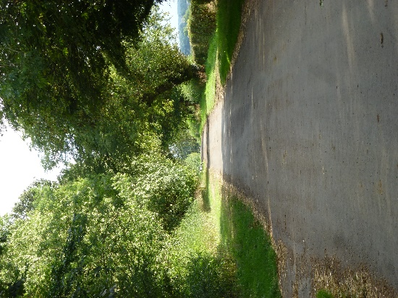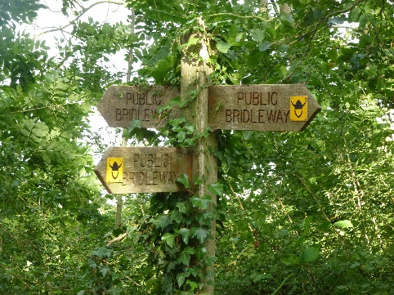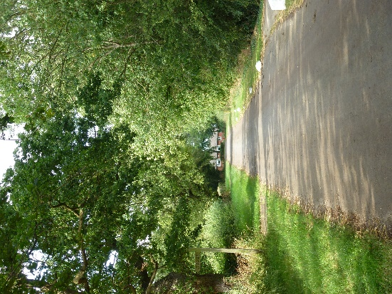
View looking South View looking North

The rich historic past of the Viking Way dates back to the 9th Century when the Vikings invaded and occupied the area which the trail crosses. Many prehistoric settlements were established on dry ground in the Lincolnshire Wolds and on the Limestone Heath with the route of the Viking Way passing sites of these early settlements. Having a route of such historical importance deserves preserving.
Due to its peacefulness and proximity to the village the Way is used extensively for exercise and recreation. It is frequently used by joggers, walkers, cyclists and horse riders from this village and others, even residents from Lincoln commute to exercise in this picturesque area of the Lincolnshire.
Although on the edge of the populated village a myriad of wildlife can be seen in the area. Foxes, deer, rabbits, hawks, buzzards, wildfowl, wild flowers and blossom trees can all be seen from this short section of path.
- To map below shows highlighted green the section of the Viking way we are nominating for allocation Along with the wooded hedge lines either side. It is approximately 3.2Ha and 650m in length. The section to the south of our nominated length sits in an area of flood zone 3 and the section to the north is in open countryside, both already benefit from protection from development in the CLLP and NPPF.

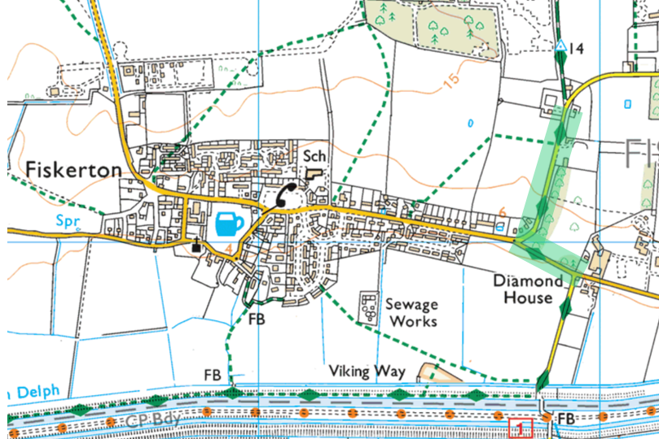

☐ Please tick if you are submitting more information relating to the above representation

Please submit your comments to: talkplanning@central-lincs.org.uk or Central Lincolnshire Local
Plan Team, c/o North Kesteven District Council, Kesteven Street, Sleaford NG34 7EF.
If you need assistance, call 01529 414155 or email talkplanning@central-lincs.org.uk.

Thank you for taking the time to respond

